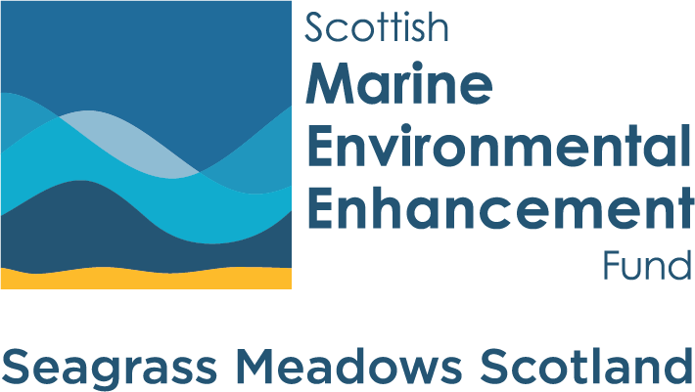

Seagrass Meadows Scotland – Guidance for applicants
This document provides further supporting guidance on applying to and receiving funding SMEEF.

Terms and Conditions of funding
For legal purposes SMEEF is considered part of NatureScot. Following this, all SMEEF grants are subject to NatureScot’s Standard Terms and Conditions of Funding. Please ensure that you have read and understood these terms and conditions before applying.

Submitting your application
All applications must include completed versions of the Seagrass Meadows Scotland Application Form, Project Budget template and a map showing the project location. Applications should be submitted to grants@smeef.scot by noon on 24th November 2025. We are unable to accept applications received after this deadline.
Please use the following naming format: ‘Organisation name_SMEEF _ Seagrass Meadows Scotland _ Application Form’.
If you need help using the Application Form or Project Budget template, please contact a member of the SMEEF team at grants@smeef.scot as soon as possible.

Project budget and costs
When applying to Seagrass Meadows Scotland you should provide details of your project’s costs and funding by completing our Project Budget template. The template provides space for you to tell us about the costs of delivering your project, the amount being requested from SMEEF, and who else you expect to contribute support to the project. Please follow the guidance given below when completing the template.
Value Added Tax (VAT)
We cannot pay any VAT that you will be able to reclaim from HM Revenue and Customs (HMRC). You should not include these amounts in your request to SMEEF.
Where you will not be able to reclaim VAT from HMRC, we can cover the costs of irrecoverable VAT. You may include these amounts in your request to SMEEF.
Budget categories
The budget template gives several categories under which to allocate your project costs. This is designed to help us to understand your project budget and the types of costs involved more easily. Please see the information for applicants for further information on the types of costs we can support under the Seagrass Meadows Scotland programme.

Procurement guidelines
SMEEF grants are subject to NatureScot’s rules on procurement. All Applicants should demonstrate good procurement practice by inviting open and fair competitive quotes, emails are acceptable, and tenders as outlined below (Note - Public Bodies should follow their own purchasing procedures to ensure public accountability).
You will need to keep appropriate financial information and records to support purchasing decisions. Further guidance on procurement is provided here.
Purchasing thresholds (including any non-recoverable VAT) | Minimum Competition Requirements | Further information and approvals that will be required
£1,000 and below | x 2 Quotes – to enable a value for money comparison | None
£1,000 to £25,000 | x 3 Written Quotes - a minimum of 3 suppliers to be invited to quote. | Justification required if other than lowest quote is opted for  Explanation required if only one quote received
£25,000 to £50,000 | x 5 Written Quotes - a minimum of 5 suppliers to be invited to quote | Justification and approval required if 5 suppliers not invited to quote  Justification and approval required if other than lowest quote is opted for  Justification and approval required if only one quote received
£50,000 and above | Advertise and full procurement tendering exercise | Public Contracts Scotland (PCS) portal is the preferred route to advertise all contract tender opportunities and MUST be used for all contracts of £50,000 and over, inclusive of VAT.  Contracts must be advertised for a minimum of 3 weeks  Supply only contracts may be procured out with PCS with our prior approval. A minimum of 5 written quotes must be invited with approval requirements as set out in the £25,000 - £50,000 threshold above.  Approval required if only one tender received (no competition)

Fair Work First
Fair Work First is the Scottish Government's flagship policy for driving high quality and fair work across the labour market in Scotland. This is increasingly being implemented by applying fair work criteria to grants, other funding and contracts being awarded across the public sector, where it is relevant to do so. Through this approach the Scottish Government is asking employers to adopt fair working practices, specifically:
• appropriate channels for effective voice, such as trade union recognition
• investment in workforce development
• no inappropriate use of zero hours contracts
• action to tackle the gender pay gap and create a more diverse and inclusive workplace
• payment of the real Living Wage
• offer flexible and family friendly working practices for all workers from day one of employment
• oppose the use of fire and rehire practice
As a result, we are introducing two elements of the Fair Work First policy for all new grant offers. These criteria are for employees to receive at least the real Living Wage, and for workers to be provided with appropriate channels for effective voice. Please ensure that you have read NatureScot’s ‘Fair Work First – guidance for funding applicants’ before applying.

Value for money
All applicants must be able to demonstrate how they will get the best value for money for SMEEF funds, including how the project will:
• minimise costs
• get the best value from the resources available
• use suitable and effective project management methods
To help achieve this you must get competitive quotes and tenders for all goods, works and services in accordance with the procurement guidelines set out above.

If your application is successful
We are hoping to confirm the outcome of all applications by December 2025. If your application is successful, we will send you a grant agreement to consider, including
• a grant offer letter
• your terms and conditions
• any relevant updates about your application
You then must check your grant agreement. It sets out the terms and conditions of your grant offer and any specific conditions that apply, including:
• the start and end date of your agreement
• the amount of your grant
• your payment schedule
• expected outputs
• the evidence you must give to justify payment claims, such as timesheets, invoices and reports
• what will happen if you do not meet the terms and conditions of your grant
You, or someone from your organisation authorised to enter into a grant agreement, must accept or reject the offer, sign the agreement in line with the instructions in the grant offer letter and return it to us within 10 working days. We may withdraw or reduce your grant offer if your project changes or costs increase.

Acknowledging your grant
One of the conditions of receiving funding from SMEEF is that you acknowledge our funding during the contract period outlined in your grant offer letter. We may also ask you to tell us how you plan to acknowledge our funding before making a formal grant offer. Further details on how to acknowledge a grant from SMEEF are provided on our website here.
If your application is unsuccessful
Please note that due to team capacity, we may be unable to provide unsuccessful applicants with feedback on why their project has not been supported.
Queries
If you have any questions about SMEEF or how to apply to the Seagrass Meadows Scotland programme, please contact us by email at grants@smeef.scot.

