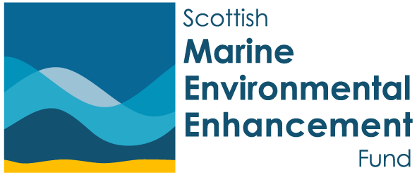


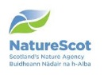


Prospectus
2026
SMEEF is managed by:

Scottish Marine Environmental Enhancement Fund

About
The Scottish Marine Environmental Enhancement Fund (SMEEF) is an innovative mechanism for linking philanthropic donations from business with strategic interventions to improve the health of Scottish coasts and seas.
Managed by Scottish Governments’ Marine Directorate, Crown Estate Scotland and NatureScot and using science-based, policy aligned criteria, the grant pots created are distributed to projects across Scotland.
The unique placement of SMEEF provides exceptional insight and assures robust governance and transparency.
SMEEF has sourced nearly £10m since it’s start in 2022 and funded more than 100 grants. Unfortunately, demand continues to exceed supply approximately 2 to 1 and the supply of finance is limited in coming years.

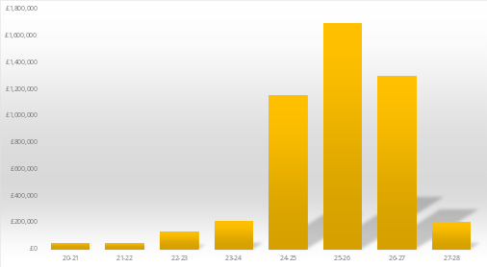

Core Aims
SMEEF is an effective, science led, long-term funding mechanism that will:
Enhance marine habitats and species across Scottish coasts and seas,
Take a systems view, connecting interventions and considering full ecosystems and life cycles,
Provide demonstrable ESG/CSR opportunities, and
Encourage wider research and development.

Achievements

SMEEF has already distributed 105 grants across our four grant themes in all Scottish marine regions.

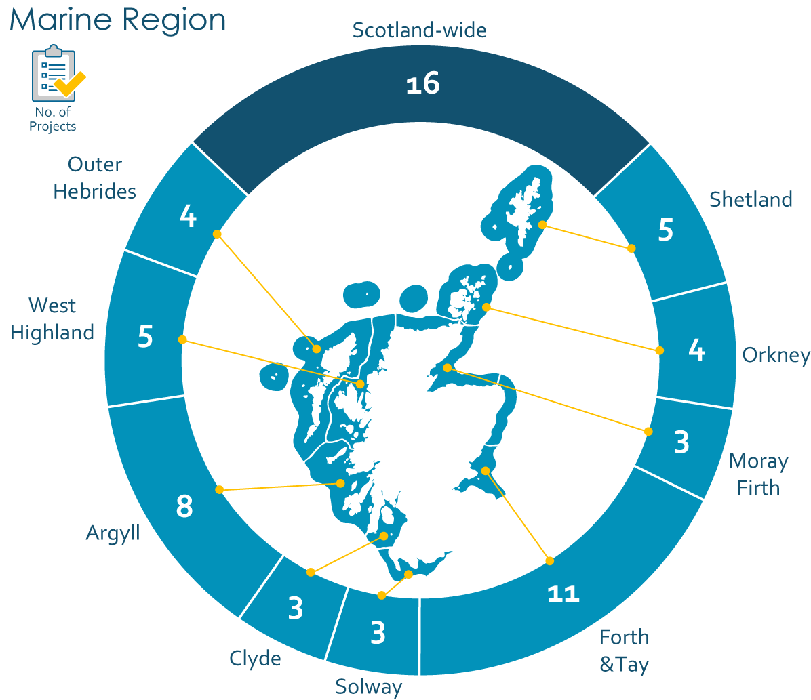

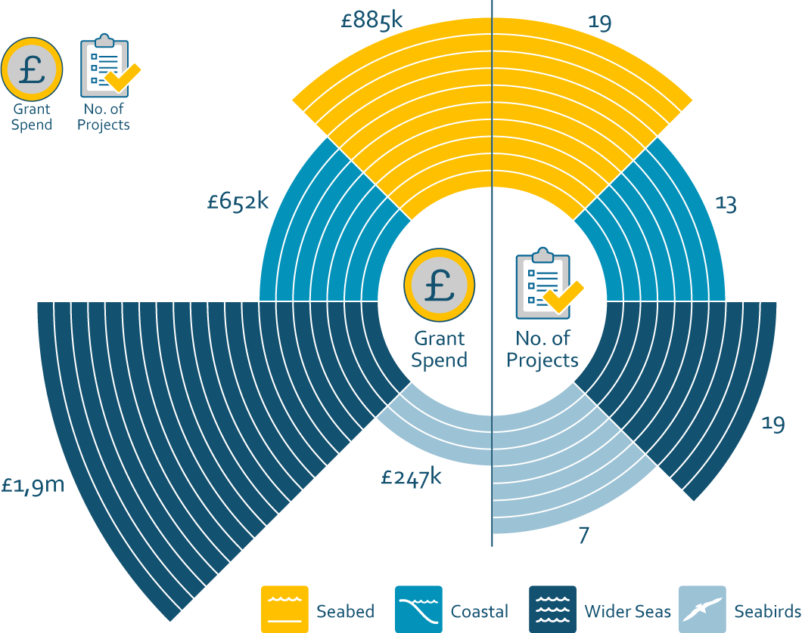

Policy Alignment

Our grant giving strategy follows the best and most up to date science, giving donors reassurance that projects are placed to greatest effect. We work closely with the Scottish Government to ensure the projects we fund contribute towards relevant policy priorities at national, regional and local level.
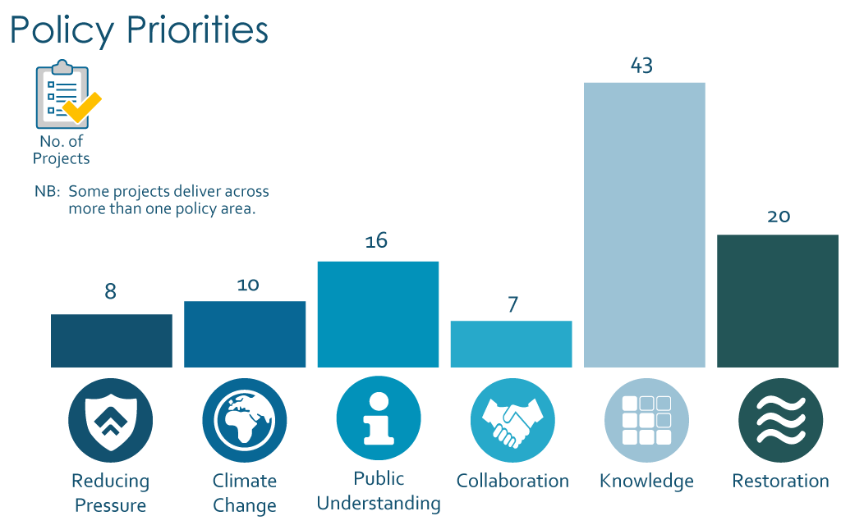
Policy areas considered most relevant to SMEEF are Scottish Biodiversity Strategy, Scottish Seabird Strategy and the Scottish Whale and Dolphin Conservation Strategy. The table above demonstrates delivery against the high-level themes from these policies.

What can SMEEF achieve for Business?
By working closely with policy makers we create a pipeline of marine enhancement projects which test new approaches to delivery and provide an evidence base to support the emerging needs associated with strategic compensation, nature positive policies and other businesses and nature related policy areas.
Businesses can join at a level and time suitable for their operation.

Donors
Core funding comes from Crown Estate Scotland, Scottish Government’s Marine Directorate and NatureScot (in-kind/hosting). In addition, SMEEF would like to thank the following corporate donors:
20/21 | Red Rock Power Limited  Vattenfall Wind Power Limited  Scottish Power Renewables (UK) Limited  Ocean Winds UK Limited | 23/24 | Simply Blue Energy (Scotland) Limited  Muir Mhor Offshore Wind Farm Limited  Bellrock Offshore Wind Farm Limited  Broadshore Offshore Wind Farm Limited  Scottish Power Renewables (UK) Limited  Scottish Hydro Electric Power Distribution Limited
21/22 | EDF Energy Renewables Limited  SB Offshore Energy Limited  UK Mainstream Renewable Power Limited  Simply Blue Energy (Scotland) Limited  RWE Renewables UK  SSE Renewables Services (UK) Limited  Offshore Wind Power Limited | 24/25 | Ossian Offshore Wind Farm Limited  Stromar Offshore Wind Farm Limited  Scottish Hydro Electric Power Distribution Limited  Muir Mhor Offshore Wind Farm Limited  Bellrock Offshore Wind Farm Limited  Broadshore Offshore Wind Farm Limited  Thistle Wind Partners Limited  Orsted Power (UK) Limited  CampionWind Limited  MarramWind Limited  Morven Offshore Wind Limited
22/23 | Scottish Power Renewables (UK) Limited  Orsted Power (UK) Limited  Stromar Offshore Wind Farm Limited | 24/25

Accountability
SMEEF has established the following robust governance arrangements to provide clear and accountable reporting processes.
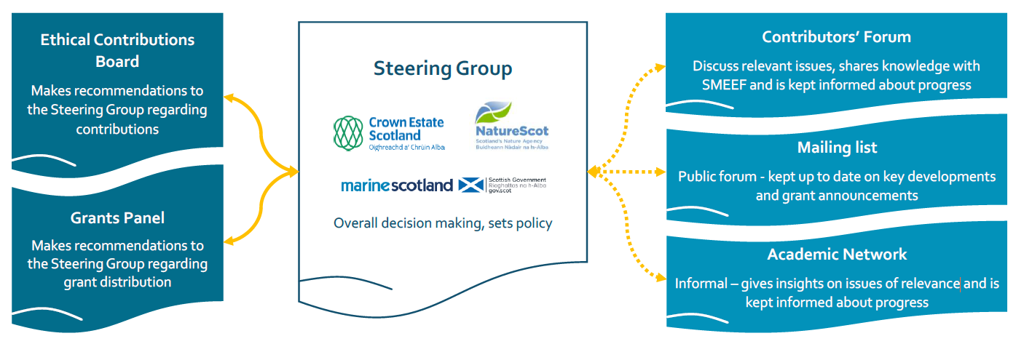

The SMEEF Ethical Contributions Board assess donors and a separate Grants Panel decide the grant allocations. SMEEF takes around 10% of donations to cover costs.

The Benefit to Business
SMEEF has a proven track record of delivering:
- £9.5m of investment already creating jobs and outcomes for nature through 105 projects.
- Unique funding model enables businesses to demonstrate their commitment to nature.
- Due diligence procedures provide protection from greenwashing.
- Contributors Forum gives opportunity for discussion and insights to be shared witeh policy and decision makers.
If you have any queries please contact manager@smeef.scot.

Contact
Sarah Brown, Partnerships Manager
manager@smeef.scot | 07717 571762
www.smeef.scot
Photos. Front: Loch Ryan © Edinburgh Napier University; Seagrass © UHI Shetland
Back: Sandwood Bay © NatureScot/Lorne Gill

